# End User Guide - Partner Admin & Policy Manager

## What all activities does a 'Partner Admin' perform?

Partner Admin supervises the overall partner and policy management functionalities in PMS. The admin is responsible for uploading Root and Intermediate CA Certificates, manage partners and policies, Approve/ Reject new entries created by different partners and deactivate partner related records wherever applicable

Partner Admin can also create and manage policy groups and policies, similar to the role of Policy Manager.

## ****What all activities does a 'Policy Manager' perform?****

In UI- both PARTNER_ADMIN and POLICYMANAGER roles should be granted for the ‘**POLICIES**’ card to appear in the dashboard.

As a partner admin cum policy manager - creation and management of Policy Group, Authentication Policy, Datashare Policy is enabled within Policies card.

**Partner Admin/ Policy Manager login flow**

To begin with, partner admin has to be registered himself just like any other partner registration by selecting any one of the partner type., ie, Admin has to register in PMS with any one of the partner type.

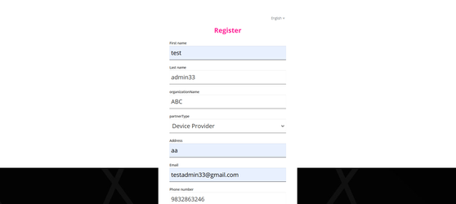

Steps to configure **PATNER_ADMIN/POLICYMANAGER** role in keycloak:

1. After registration, go to keycloak and search your user name in Users tab.

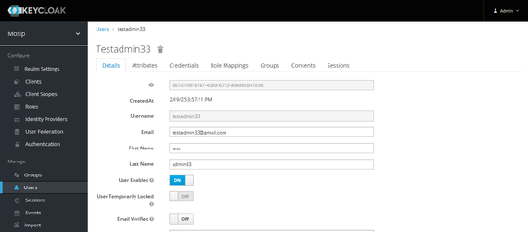

1. Go to the **Role Mapping** tab.

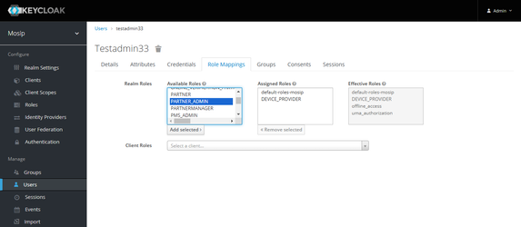

1. In the **Available Roles** section, select **PARTNER_ADMIN** or **POLICYMANAGER**, click **Add** to move the selected role to the **Assigned Roles** list.

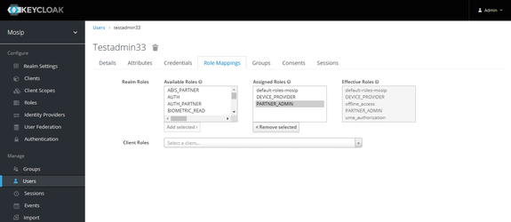

1. Log in to the **PMS** portal with the same user credentials, you should now have access to the **Admin Dashboard**.

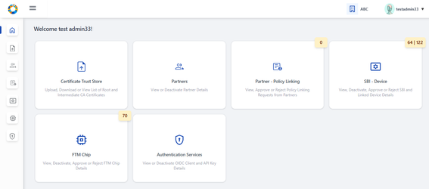

**Note:** Add POLICYMANAGER role if Policies card should be made accessible in UI

By following the above steps (1-4) in keycloak, the admin can also configure POLICY_MANAGER role to view and manage **Policies** card as shown in the dashboard below:

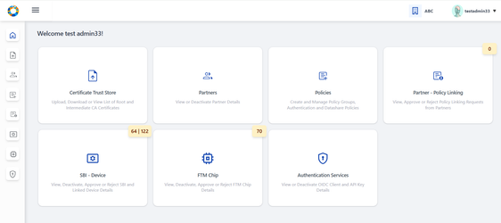

**Note** that if only POLICYMANAGER role is configured in keycloak, then the user will still be able to access as a normal partner. Hence PARTNER_ADMIN & POLICYMANAGER roles are necessary to access all the cards above.

After configuring the roles and if PMS portal is still logged in, make sure to logout and login again for the roles to get updated.

**i. Certificate Trust Store:**

Certificate Trust Store provides features such as Upload, Download, View Root CA and Intermediate CA certificates to Partner Admin so that at the time of CA Signed Certificate upload by partner- MOSIP verifies the certificate chain of trust and then signs the partner’s certificate using MOSIP(PMS) private key.

**Root Trust (Root CA)** **Certificate features-**

* Upload certificate- Partner Admin can upload **Root CA** certificate so that the root of trust can be verified when an intermediate CA is uploaded.
* Partner Admin can download the uploaded root certificate as and when needed.
* Tabular view of all uploaded Root CA certificates is displayed.
* View certificate details- Uploaded root certificate details is displayed individually.

**Intermediate Trust (Intermediate CA)** **Certificate features-**

* Upload certificate- Partner Admin can upload **Intermediate CA** certificate so that the root of trust can be verified when a partner uploads Partner / FTM Chip Certificate.
* Download Certificate Chain of Trust- Partner Admin downloads the certificate chain of trust of intermediate certificate as and when needed.
* Tabular view of all uploaded Intermediate CA certificates is displayed.
* View certificate details- Uploaded intermediate certificate details is displayed along with the list of certificates within the certificate trust chain.

**Root CA Certificate:**

In Certificate Trust Store, the user views the list of Root CA Certificates uploaded by admin till date with details such as certificate ID, partner domain, issued to, issued by, validity period, validity status (valid/ expired) etc.

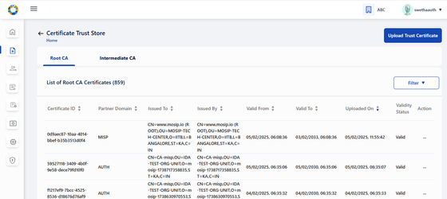

Each active certificate record has two options in action menu- **View** and **Download** Certificate.

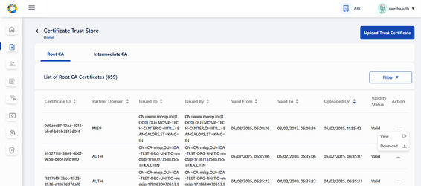

On clicking View, the Root CA certificate detail can be viewed individually.

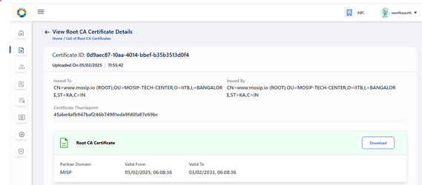

In the same page, an option to download the Roo CA certificate in .p7b file is also provided. Clicking on download, a success message appears.

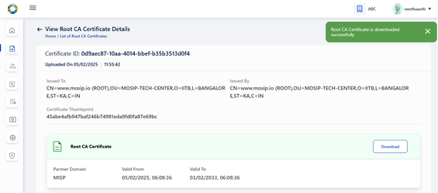

On opening the .p7b file from local system, the Root CA Certificate can be viewed as below:

NOTE: any external installation required [swetha.N](https://mosip.atlassian.net/wiki/people/636a272c11c69c7418450dbe?ref=confluence) [Prathmesh Jadhav](https://mosip.atlassian.net/wiki/people/712020:c6ee5f54-fc2c-4d62-986e-97ddd067ffd0?ref=confluence) ???

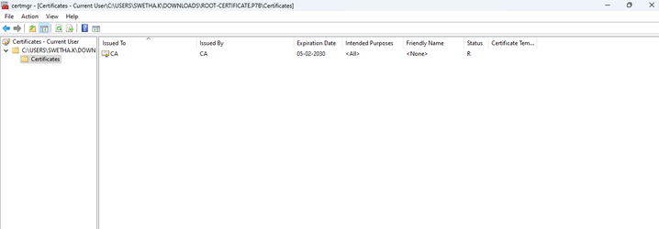

To upload Root CA/ Intermediate CA Certificate, click on ‘Upload Trust Certificate’.



Admin is thus navigated to Upload Trust Certificate page.

Note: Admin can upload Root CA/ Intermediate CA certificate in the same page but should be in a sequential order.

ie. Root CA Certificate upload first and then Corresponding Intermediate CA certificate upload.

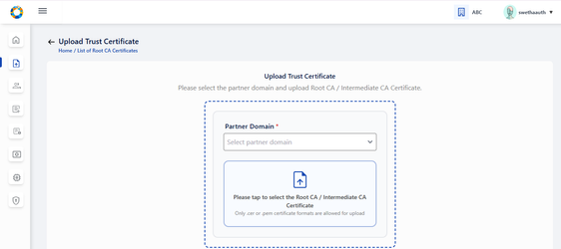

Select the partner domain (AUTH/ DEVICE/ FTM) **in the Upload section** . Partner Domain typically refers to the specific functional area for which the **Root or Intermediate CA certificate** is being uploaded.

**Note:**

Select Partner domain as AUTH if **Root or Intermediate CA certificate** is being uploaded for Authentication Partner.

Select Partner domain as DEVICE if **Root or Intermediate CA certificate** is being uploaded for Device Provider.

Select Partner domain as FTM if **Root or Intermediate CA certificate** is being uploaded for FTM Chip Provider.

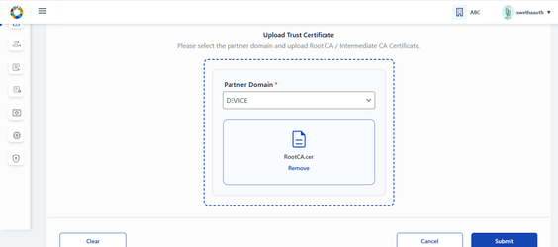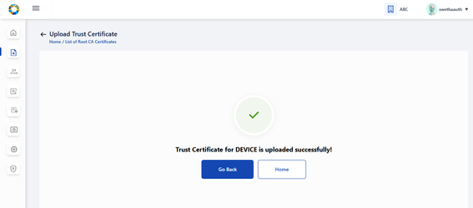

**note:**

* only .cer or .pem format certificates are allowed for upload
* Future dated certificates should not be allowed for upload. Else throw an error message.
* Only Version 3 certificate should be allowed for upload.
* If the corresponding root certificate is not uploaded, then while submitting the Intermediate certificate upload, an error message- 'Please upload corresponding Root Certificate to proceed further'

**Note for Root CA Certificate:**

* Issued To and Issued By is the same - which means these are self signed certificates.

**Note for Intermediate CA Certificate: :**

* The Subject of the root certificate matches the Issuer of the intermediate certificate.
* Issued To and Issued By are different, as the intermediate CA certificate is signed by the Root CA.
* Intermediate certificate must expire before its root certificate.
* Validity of Root CA Certificate > Intermediate CA Certificate > CA Signed Partner Certificate
* Sequence of Upload: Root CA Certificate (by Partner Admin)→ Intermediate CA Certificate (by Partner Admin) → CA signed Partner Certificate (by Partner)

**List of Root CA Certificates:**

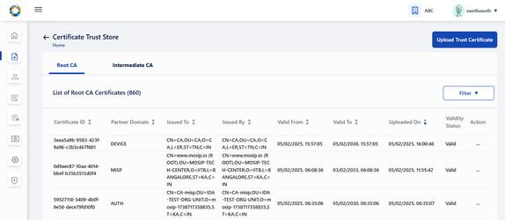

**List of Intermediate CA Certificates:**

On clicking the Intermediate CA tab, List of all Intermediate CA certificates uploaded by Partner Admin is displayed.

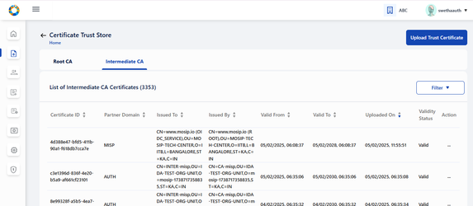

Action menu for all active certificates displays the following options : View , Download Certificate Chain

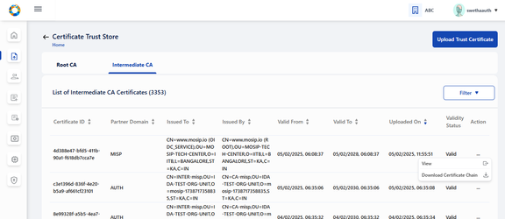

Either by clicking on the row item or the View option in action menu, the admin is navigated to View Intermediate CA Certificate details page where the certificate details such as Certificate ID, Partner Domain- (AUTH, FTM, DEVICE), Issued To- <subject > field of Certificate, Issued By- <issuer > field of Certificate, Valid From, Valid To- same as system browser date format etc are displayed

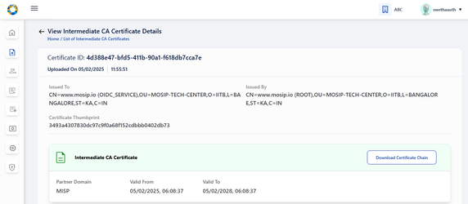

Clicking on Download, downloads the entire certificate chain as .p7b file and a success message is displayed - 'Certificate Chain of Trust for the given Intermediate CA certificate is downloaded successfully'

**Note:** For expired status, ‘Download Certificate Chain’ button will be disabled in View Root Certificate page/ Tabular View page

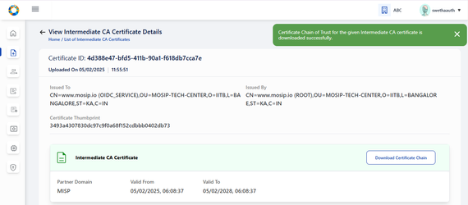

On clicking the .p7b file from local system, the certificate heirarchy of the intermediate CA certificate is present where its corresponding root certificate is also downloaded.

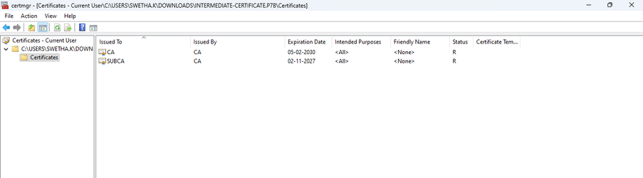

To upload the Intermediate CA certificate, carry out the same steps of Root CA Certificate upload.

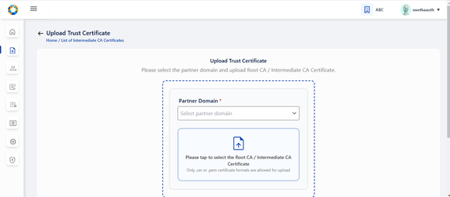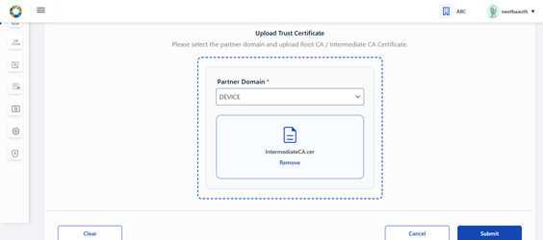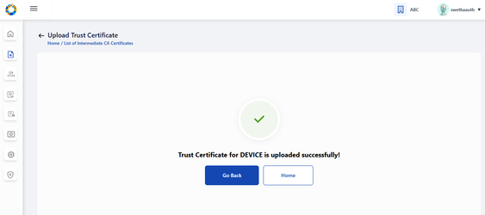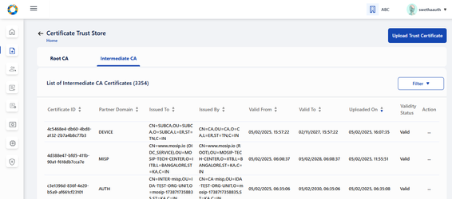

**ii. Partners:**

As a Partner Admin, he can view the list of all partners who have enrolled to PMS portal by clicking on the Partners card is dashboard/ side panel/ hamburger menu, so that their consolidated details along with partner certificate details is available all in one screen.

This card has the following features:

1. Tabular View of Partner detail (Action menu: View, Deactivate)
2. View individual Partner detail and with certificate details
3. Download original partner certificate and MOSIP Signed certificate
4. Deactivate Partner

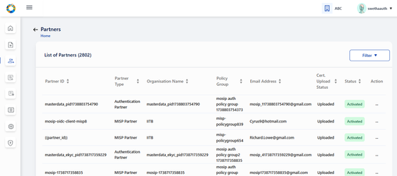

2 options in action menu: View , Deactivate

**Note:** Deactivate option is disabled once the partner has been deactivated.

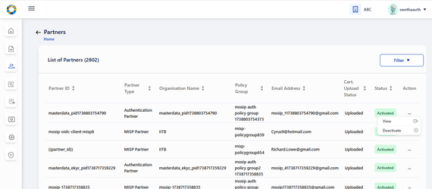

Either on clicking the View option in action menu or by clicking on the row item itself, the admin is navigated to View partner details page where info such as Partner type, organisation name, first name, last name, phone number, email address, policy group (only if partner is authentication partner). Partner certificate details are also visible.

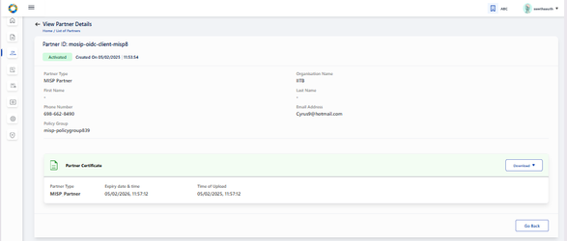

The admin can download original certificate/ MOSIP Signed certificate as and when necessary.

**Note:** The download functionality of following certificates is possible only during following instances:

* This button is enabled only for Activated partner record whose certificate is already uploaded
* This button is disabled for deactivated partner records/ partner records whose partner certificate is not uploaded yet.
* If Original Certificate/ MOSIP Signed Certificate is expired, then on clicking respective menu items in the button-dropdown - an appropriate error message is displayed.

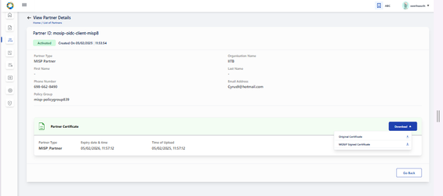

On downloading the Original / MOSIP Signed certificate, a success message appears.

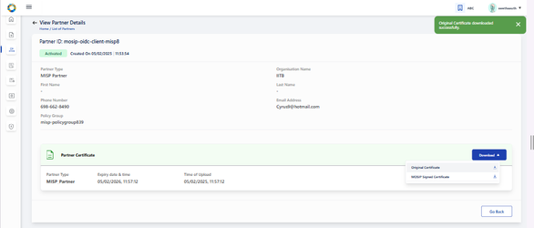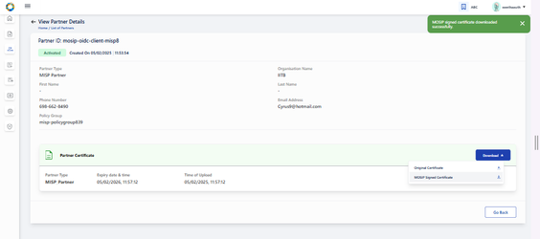

To deactivate a partner, click on Deactivate option in action menu. A popup window appears seeking for confirmation from the partner

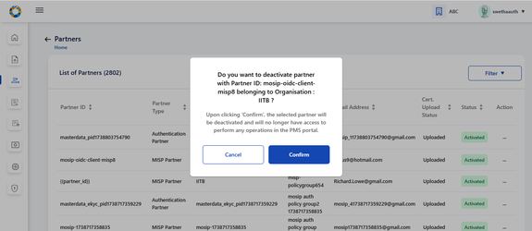

After confirming deactivation, the respective record is greyed out in the tabular view.The action menu here should be enabled with only View option. (Deactivate in action menu is disabled)

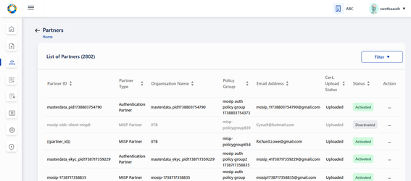

**Note:** After deactivation, the View partners page will display the following-

1. 'Deactivated' status
2. Certificate section is greyed out with and download button is disabled.

The deactivated partner will not be able to create or utilize any of the services in their PMS portal (For eg: no new transactions will work such as creation of OIDC Client , API Key etc).

**Known Issue:** Even after partner deactivation, partner is able to access the existing transactions in their PMS portal such as,

1. Existing OIDC client ids are still operational for Authentication Partner.
2. Existing API keys are still operational for Authentication Partner.
3. SBI / Devices / FTM - trust validation does not fail even after partner deactivation.

**iii) Policies**

This card is accessible only if both Partner Admin and Policy Manager roles are configured.

In UI- both PARTNER_ADMIN and POLICYMANAGER roles should be granted for the card to appear in the dashboard.

As a partner admin cum policy manager - creation and management of Policy Group, Authentication Policy, Datashare Policy is enabled within Policies card.

l

On clicking Policies card, 3 Tabs- **Policy Group, Authentication Policy, Datashare Policy** are displayed. Policy group tab is selected by default.

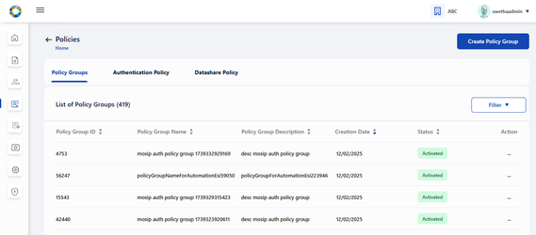

**I. Policy Group features:**

a) Create Policy Group

b) Tabular view of previously created Policy Groups along with the stat

c) View created Policy Group details individually

d) Deactivate Policy Group

**II. Authentication Policy features:**

a) Create Authentication Policy by mapping to an already created Policy Group

b) Tabular view of previously created Authentication Policy along with the status

c) View created Authentication Policy details

d) Deactivate Authentication Policy

e) Clone Authentication Policy in different policy groups on clicking Clone option in action item of activated/ deactivated records in Tabular view screen

f) Edit Authentication Policy which is in draft status

g) Publish Authentication Policy which is in draft status so that the status changes to ‘Activated’.

**III. Datashare Policy features:**

a) Create Datashare Policy- clicking on this button navigates to Create Policy Group

b) Tabular view of previously created Datashare Policy along with the status

c) View created Datashare Policy details

d) Deactivate Datashare Policy

e) Clone Datashare Policy in different policy groups on clicking Clone option in action item of records in Tabular view screen

f) Edit Datashare Policy which is in draft status.

g) Publish Datashare Policy which is in draft status so that the status changes to ‘Activated’.

**Policy Group:**

All the policy groups created so far by Partner Admin/ Policy Manager are displayed on ‘List of Policy Groups’ page.



On clicking the ‘Create Policy Group’ option on the top right of the screen, we can create a Policy Group by providing suitable name and description that is self explanatory for partners, who would be selecting them during Partner Policy Request to create API Key/ OIDC Client etc.

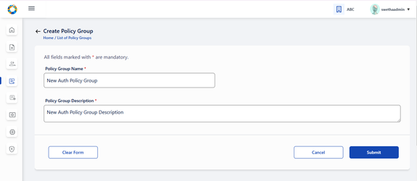

On click of Submit, a success message appears.

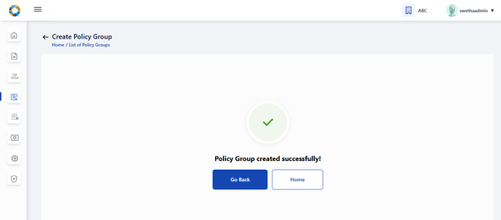

Admin can either click on ‘Go Back’ to redirect to ‘List of Policy Groups’ page as shown below or click on ‘Home’ to navigate back to Home page/ dashboard.

The options provided in 'Action menu are: View, Deactivate.

Clicking on View in action menu or by clicking the row item itself, admin is navigated to View Policy Group page where the policy group details are displayed along with its status: Activated or Deactivated.

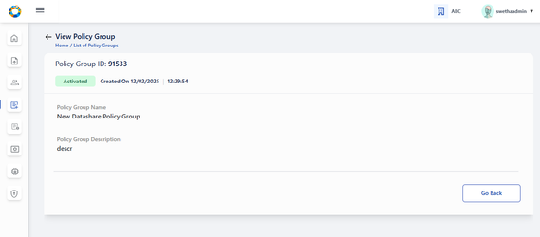

If the admin wants to deactivate the Policy Group, then click on Deactivate option in action menu

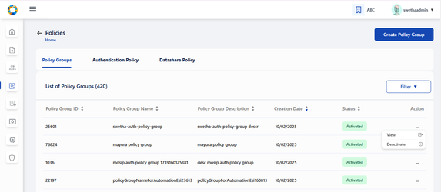

A popup window appears seeking for confirmation before proceeding to deactivate.

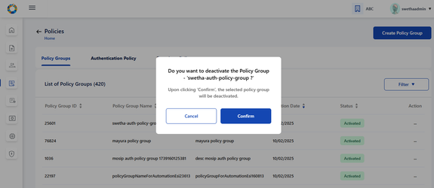

After confirming deactivation, the respective record is greyed out in the tabular view.

The action menu here should be enabled with only View option. (Deactivate in action menu is disabled)

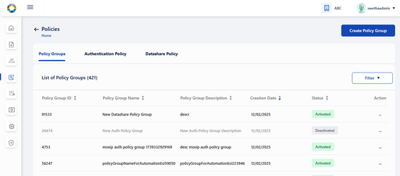

After deactivation, the View policy group page [MOSIP-36963](https://mosip.atlassian.net/browse/MOSIP-36963) will display 'Deactivated' status

Once the policy group is deactivated by policy manager, the partner will not be able to fetch this policy group in any of the screens in their PMS portal.

**Note:** Policy Group cannot be deactivated if there are active or draft policies associated to the given policy group.

If the Policy Group has active or draft policy/ policies associated to it, then on clicking Confirm, following error message is displayed along with the count of such policies-

**a) In case of Active and Draft policies associated to Policy Group:**

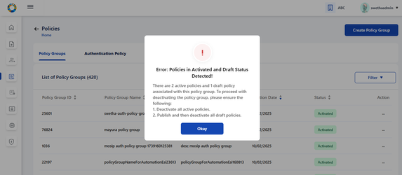

**b) In case of Active policies associated to Policy Group:**

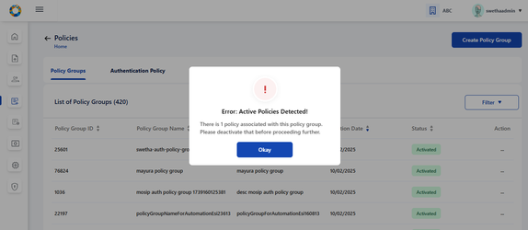

**c) In case of Draft policies associated to policy group:**

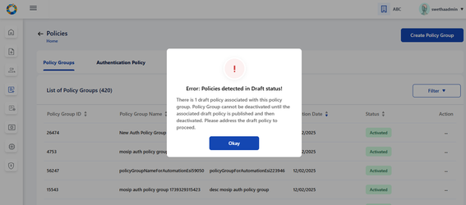

**Authentication Policy / Datashare Policy:**

On clicking Authentication Policy tab, List of all previously created Authentication Policies are displayed.

On clicking Datashare Policy tab, List of all previously created Datashare Policies are displayed.

The steps and features are same for both Authentication and Datashare Policy.

Policies can have the following status - Draft, Activated or Deactivated.

1. Only Draft or Activated row items are clickable which navigates to View Authentication Policy details.
2. Action-Action menu displays a common menu item (View, Clone, Deactivate) with only the following menu items enabled for clicking based on below statuses:
   1. Draft → Publish, View, Edit
   2. Activated **→** View , Clone , Deactivate
   3. Deactivated → View

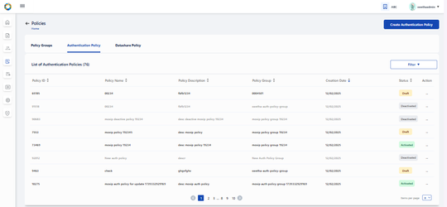

On clicking ‘Create Authentication Policy’ button, Partner Admin/ Policy manager is navigated to Create Authentication Policy page where details such as policy group, policy name, description etc will have to be entered

Note: Only active policy groups are available in the policy group dropdown.

click on the upload button to upload policy data . Only json files are allowed for upload.

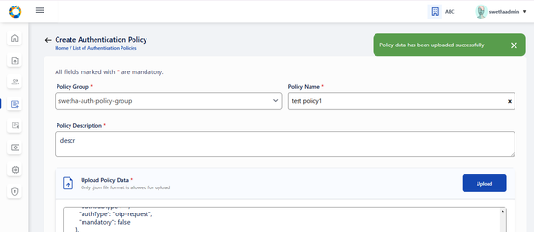

Before saving the policy in draft, the policy data can be edited in the textarea after policy data json file has been successfully uploaded.

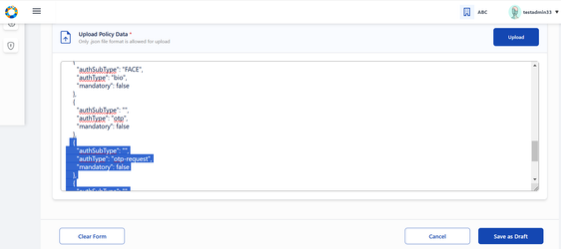

On clicking on Save as Draft, following success message appears .

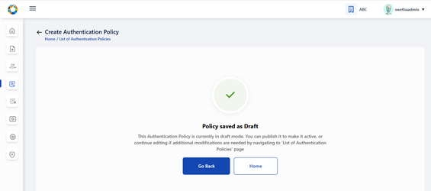

On clicking ‘Go Back’, admin is navigated back to tabular view where the policy is saved as ‘draft’ status.

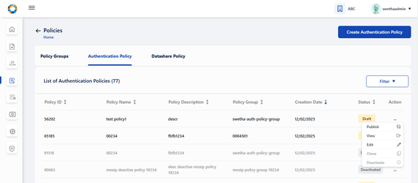

The Edit option provided to Draft policy can be used by admin to make any changes in the policy details (except policy group) before publishing the policy.

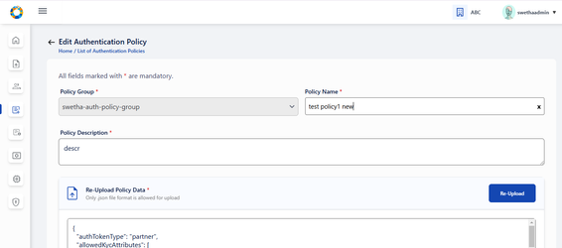

On submitting after making required changes, a success message appears.

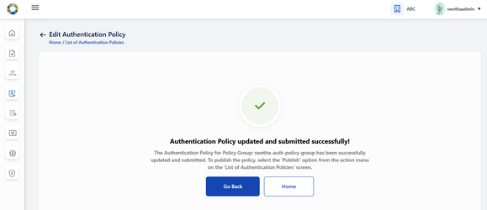

To publish policy which is currently in draft status, click on ‘publish’ option in action menu. A popup window appears seeking for confirmation to publish.

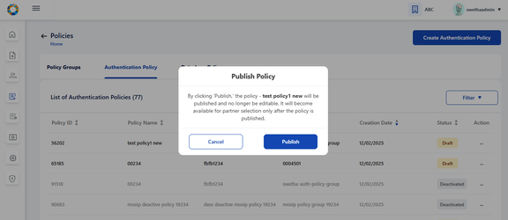

On clicking Publish, a success message appears . Click on close to close the window.

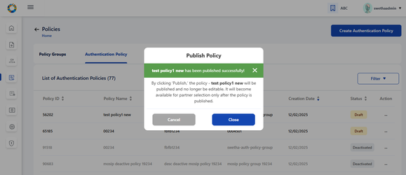

The given policy changes to ‘Activated’ status after being published. Once activated, the admin cannot edit the policy, hence the option is disabled.

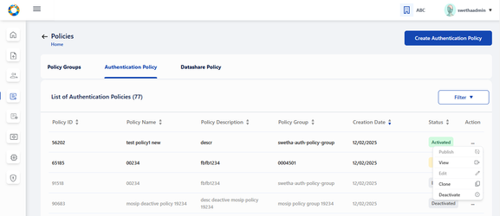

To clone any active policy onto another policy group, click on ‘clone’ in action menu. A popup window appears to select the policy group where the policy has to be cloned.

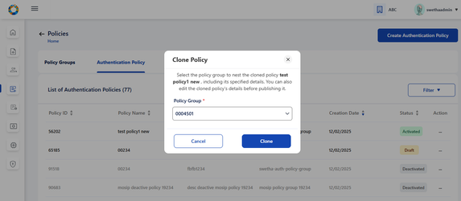

On selecting the policy group where policy has to be cloned, click on Clone and a success message appears.

Click on Close to navigate back to List of Authentication Policies screen.

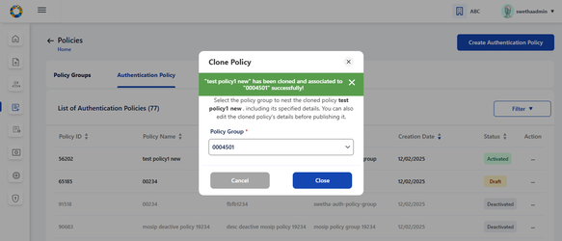

To deactivate a policy, click on Deactivate option in action menu of any activated policy record. A popup window appears seeking for confirmation.

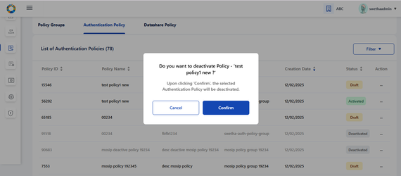

if the Policy has active partners associated to it , ie, there are Approved partner policy requests, then on clicking Confirm, following error message is displayed and the admin will be restricted to deactivate such policy groups.

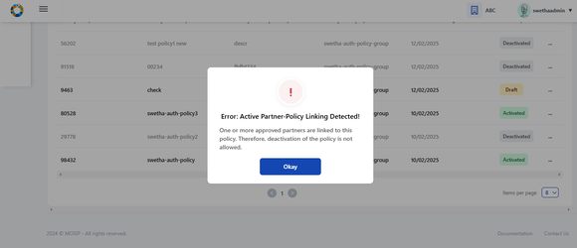

**Note:**

1. Policy can be deactivated if there are no policy requests associated with this policy
2. Policy can be deactivated if there are Rejected policy requests associated with this policy.
3. Policy cannot be deactivated if there are pending policy requests associated with this policy. In this case , following error message is displayed- ‘<title> Error: Partner- Policy Request Detected! <Description> Pending policy requests are associated with this policy. Please take appropriate action in List of Partner Policy Linking screen’
4. Once the policy is deactivated by partner admin/policy manager, the partner will not be able to fetch this policy in any of the screens in their PMS portal.

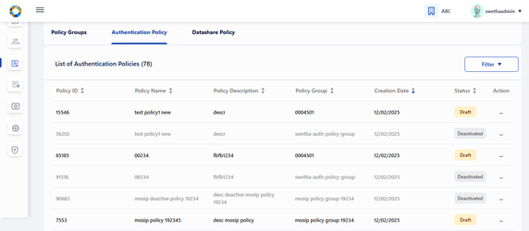

On clicking **View** option of any policy or by clciking the row item itself, admin is navigated to View Authentication Policy where policy details can be viewed. Also click on preview to view the policy data in json format.

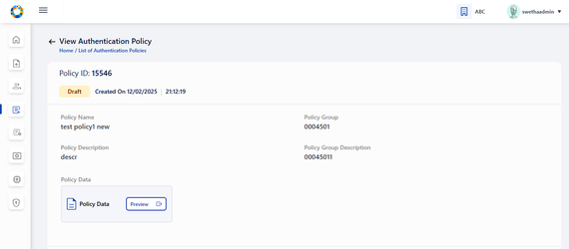

On clicking preview, policy data can be viewed in json format and an option to Download the data in local system is provided.

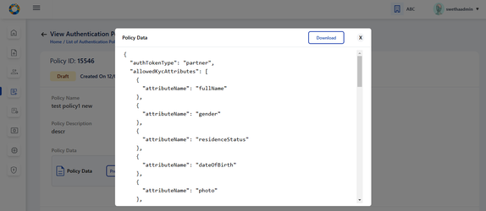

**iv. Partner - Policy Linking:**

The features provided to Partner Admin:

1. Approve/ Reject Policy requested by partner - clicking on ‘Approve/ Reject’ option in action menu of a policy record whose status is in pending for approval
2. Tabular view of Policies requested by partners along with the status
3. View individual policy request details : Either on clicking on view option in action menu of any of the active policy request in the tabular view or by clicking on the row item itself, it navigates to View Policy Request details page.

All the policy requests created by various partners are displayed in ‘List of Partner - Partner Linkages' . The different statuses possible are: Pending for Approval , Approved, Rejected, Deactivated.

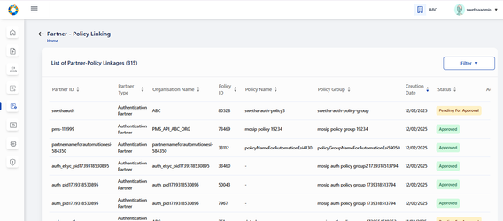

The options provided for policy linking requests in ‘Pending for Approval’ are to Approve/ Reject. Also an option to view the policy request details is also provided.

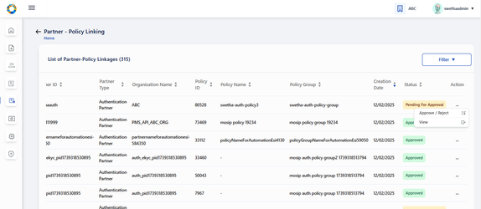

On clicking the Approve/ Reject option, the window appears - and partner admin can click on either Approve or Reject to take appropriate action

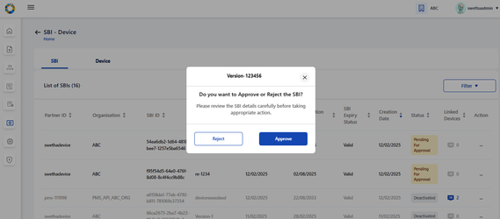

The status- Approved / Rejected gets updated in the tabular view.

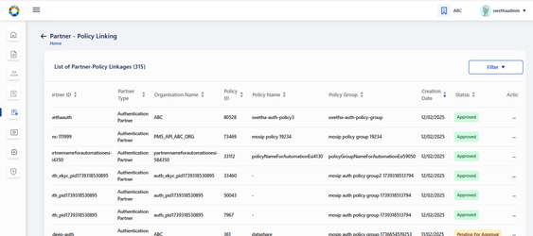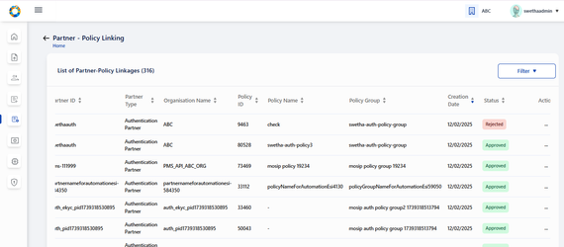

On clicking view of active record or the row item itself, the partner- policy linking view page is displayed along with comment history where partner comments and admin’s approval status is displayed.

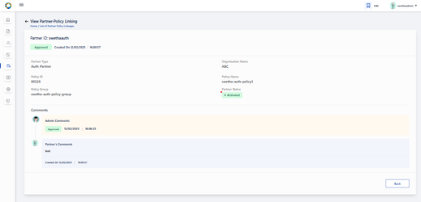

**SBI - Device:**

This card is exclusively to manage Device Provider’s requests on SBI and Device creation.

1. The 'SBI-Devices' option will have the following features:
   1. 2 Tabs- **SBI and Device** are displayed. SBI tab view is selected by default

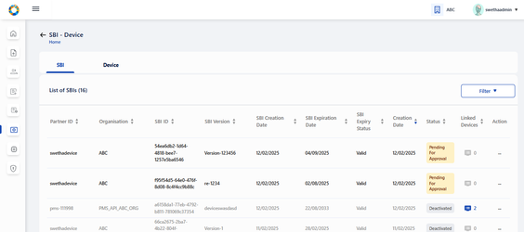

**I. SBI features:**

a) Tabular view of SBIs created by Device Providers along with the status

b) Approve/ Reject SBIs on clicking Approve/Reject in action menu of Pending for Approval records

c) View submitted SBI details : Either on clicking on view option in action menu of any of the submitted SBI details in the tabular view or by clicking on the active row item itself, it navigates to View SBI details page

d) Deactivate an SBI on clicking Deactivate option in action item of activated records in Tabular view screen

e) Linked Devices of a given SBI can be viewed through a filtered search on the pre-selected SBI

**II. Device features:**

a) Tabular view of Devices created by Device Providers along with the status

b) Approve/ Reject devices on clicking Approve/Reject in action menu of Pending for Approval records

c) View submitted Device details : Either on clicking on view option in action menu of any of the submitted API key details in the tabular view or by clicking on the row item itself, it navigates to View device details page

d) Deactivate device on clicking Deactivate option in action item of activated records in Tabular view screen

List of all SBIs created by various different device providers are available here. Any SBIs that are pending for approval can be approved/ rejected

**( to approve/ reject SBI)**

The SBI can be approved or rejected by partner admin by going to Dashboard → SBI-Device → List of SBIs.

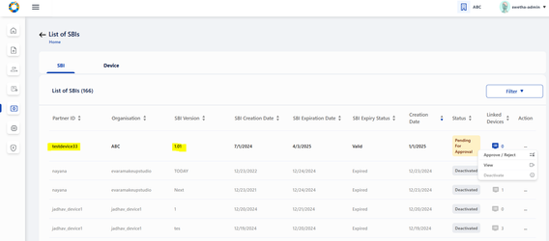

The admin selects on Approve/ Reject option from the given record and chooses appropriate action.

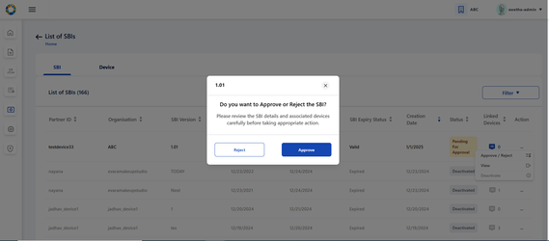

On approval, the status changes to ‘Approved’ and on rejection, the status changes to ‘Rejected’

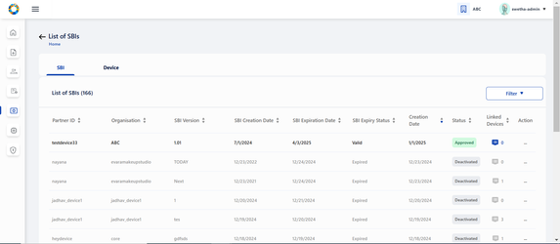

To view any individual records, click on View option in the action menu.

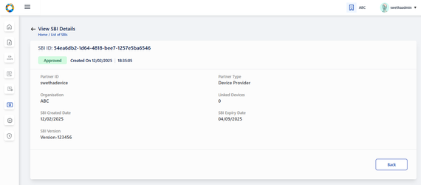

To approve or reject an SBI, select the approve/ reject option in action menu.



The approved/ rejected status is updated on the tabular view.

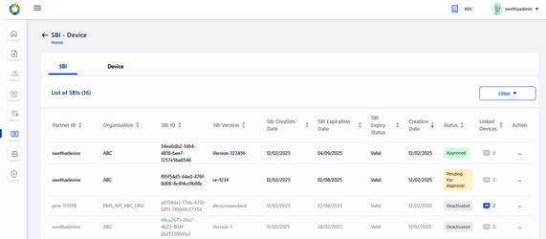

To know the list of linked devices associated to this SBI, click on the linked devices count in the tabular view or in the individual view page.

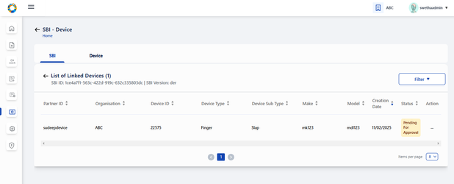

To deactivate an SBI, click on Deactivate option in action menu. An alert appears seeking for confirmation. Also admin is informed how the linked devices will be impacted after SBI deactivation.

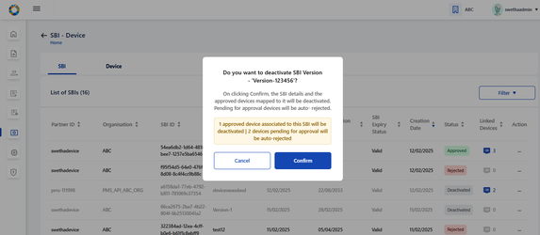

After confirming Deactivation: the respective SBI record is greyed out and the status is displayed as ‘Deactivated’.

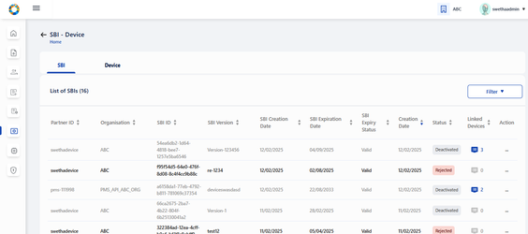

Impact of linked devices after SBI deactivation is as below:

1. All approved device records are displayed in ‘Deactivated' status and those row items being greyed out. The action menu in such records should be enabled with only View option. (Deactivate in action menu is disabled)
2. The devices whose status was ‘Pending for Approval’ before SBI deactivation will now be displayed with ‘Rejected’ status.
3. Rejected devices will continue to remain in the same status even after SBI deactivation.

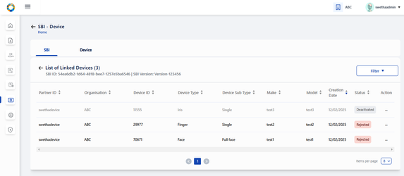

**Device:**

On clicking ‘Devices’ tab, **List of all Devices** submitted so far are displayed.

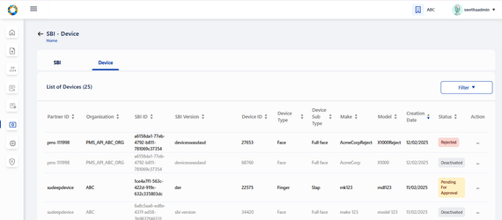

On clicking the action menu of the respective device record, an option ‘Approve/ Reject’ is provided

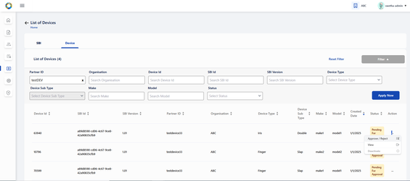

A popup window appears for the admin to take appropriate action- APPROVE/ REJECT and select the respective button

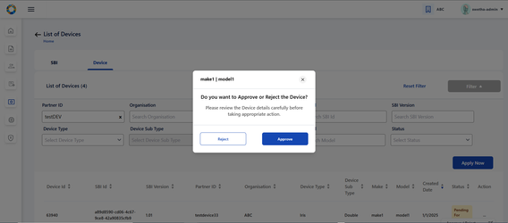

The status is thus updated accordingly in **List of Devices** Page as Approved/ Rejected based on the above action.

'Pending for Approval' status is displayed when the device request is pending with admin for approval and no action has been taken by admin yet.

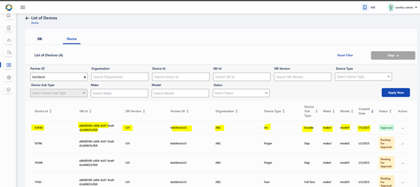

Click on view option in action menu or the row item itself (of any active device record) to view the device details individually

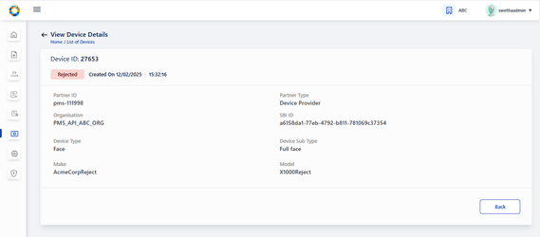

Click on deactivate option in action menu . A confirmation window appears to proceed for deactivation.

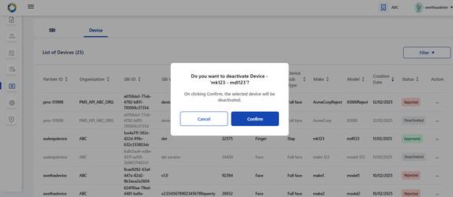

The deactivated device record is greyed out and status is also changed to ‘Deactivated’

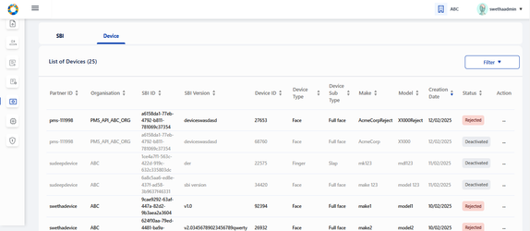

**FTM Chip:**

The following features are provided to admin to manager FTM Chip Provider’s requests:

1. Tabular view of FTM chip details along with the status of approval
2. Approve/ Reject FTM chip details submitted by FTM Chip Providers
3. View FTM details : Either on clicking on view option in action menu of active FTM Chip details in the tabular view or by clicking on the row item itself, it navigates to View FTM details page
4. Download FTM Chip Certificate : On clicking on Download option within FTM Chip Certificate section in ‘View FTM Chip Certificate’ page, then originally uploaded FTM Chip certificate can be downloaded
5. Deactivate FTM detail : On clicking on ‘Deactivate' option in action menu of approved records in Tabular view of FTM details screen, the respective FTM detail along with its certificate will be deactivated.

The List of FTM Chip details displays all FTM Chip details created by FTM Chip Provider

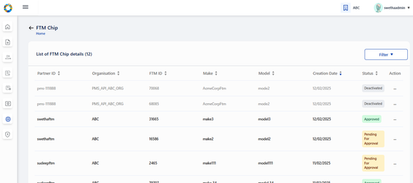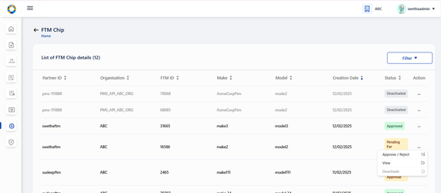

The admin navigates to ‘List of FTM Chip details’ page where list of all FTM Chip records submitted so far by different FTM Chip providers are displayed.

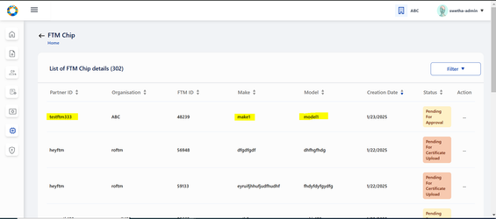

On clicking the action menu of the respective FTM Chip record, an option ‘Approve/ Reject’ is provided

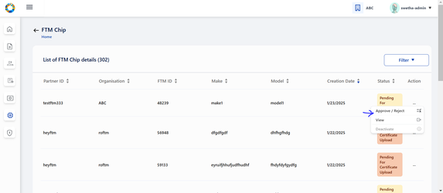

A popup window appears for the admin to take appropriate action- APPROVE/ REJECT and select the respective button

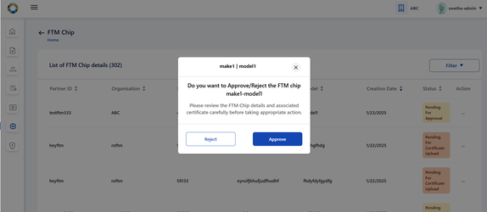

The status is thus updated accordingly in **List of Devices** Page as Approved/ Rejected based on the above action.

Note: 'Pending for Approval' status is displayed when the FTM Chip request is pending with admin for approval and no action has been taken by admin yet.

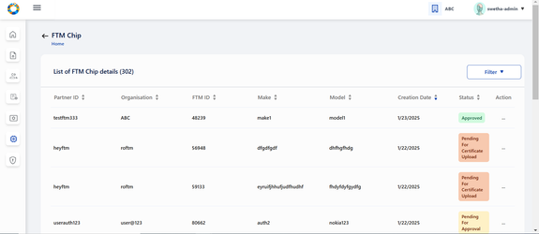

 To view FTM Chip details indivudally, click on View option in action menu

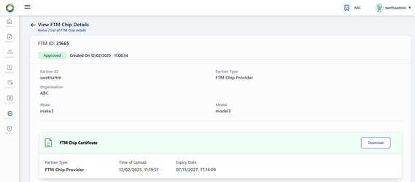

To download the FTM Chip Certificate uploaded by FTM Chip Provider, click on download button.

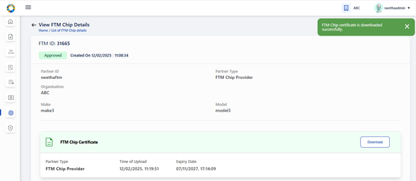

To deactivate an FTM Chip record, click on Deactivate option in action menu and a confirmation popup appears.

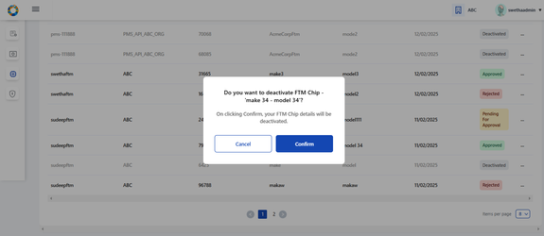

The deactivated FTM Chip record is greyed out after deactivation.

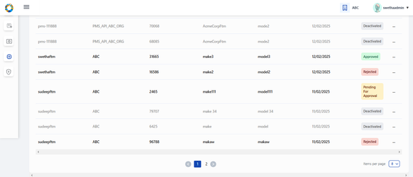

**Authentication Services:**

The screen will have the following features:

1. 2 Tabs- **OIDC Client and API key** are displayed. OIDC Client tab view is selected by default as shown in UXD.

**I. OIDC Client features:**

a) Tabular view of OIDC clients created by partners along with the status

b) View submitted OIDC Client details : Either on clicking on view option in action menu of any of the submitted OIDC details in the tabular view or by clicking on the row item itself, it navigates to View OIDC Client details page

c) Deactivate an OIDC Client on clicking Deactivate option in action item of activated records in Tabular view screen

**II. API Key features:**

a) Tabular view of API keys generated by partners along with the status

b) View submitted API Key details : Either on clicking on view option in action menu of any of the submitted API key details in the tabular view or by clicking on the row item itself, it navigates to View API key details page

c) Deactivate API key on clicking Deactivate option in action item of activated records in Tabular view screen

**OIDC Client**

Within OIDC Client tab , all OIDC Clients created by various Authentication partners are displayed.

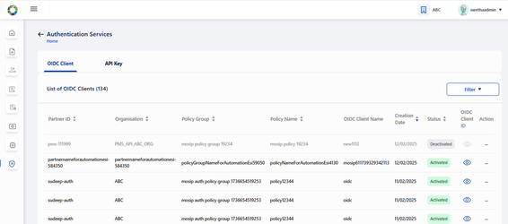

For Activated records → the action menu has two options: View, Deactivate

For Deactivated records → the action menu is enabled with only 1 option: View, Deactivate.

On clicking view option in action menu, the admin is redirected to View OIDC Client details page.

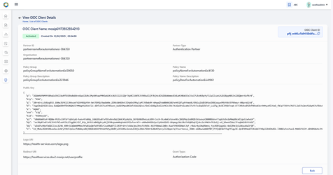

Deactivate OIDC Client:

On clicking view option in action menu, the admin is redirected to View OIDC Client details page.

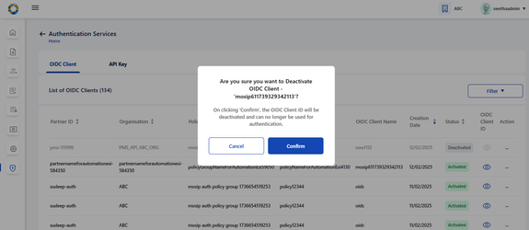

**API Key:**

To view the list of all API Keys created by Authentication partner, click on API Key tab

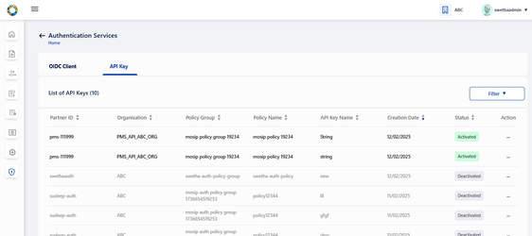

For Activated records → the action menu has two options: View, Deactivate

For Deactivated records → the action menu is enabled with only 1 option: View, Deactivate.

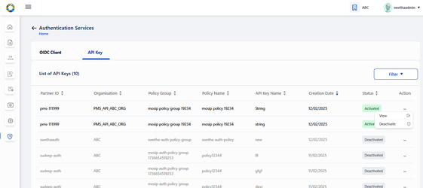

On clicking view option in action menu, the admin is redirected to View API Key details page.

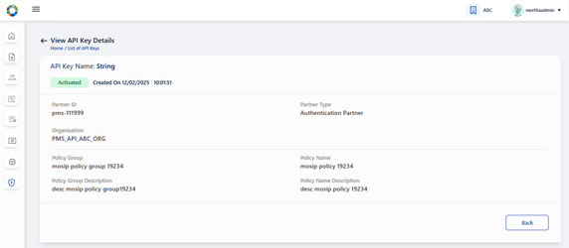

To deactivate an API Key, click on deactivate option in action menu.

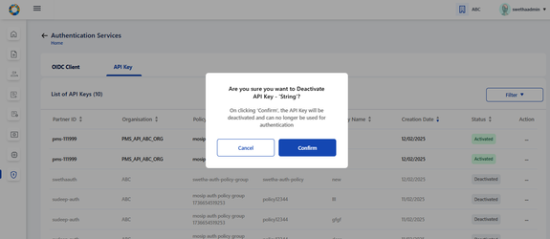

The deactivated record is greyed out and is updated with Deactivated status.

